# Order Lifecycle DEMO

Step - 1 Choose an item of your choice - https://hc-sandbox.myshopify.com/collections/all

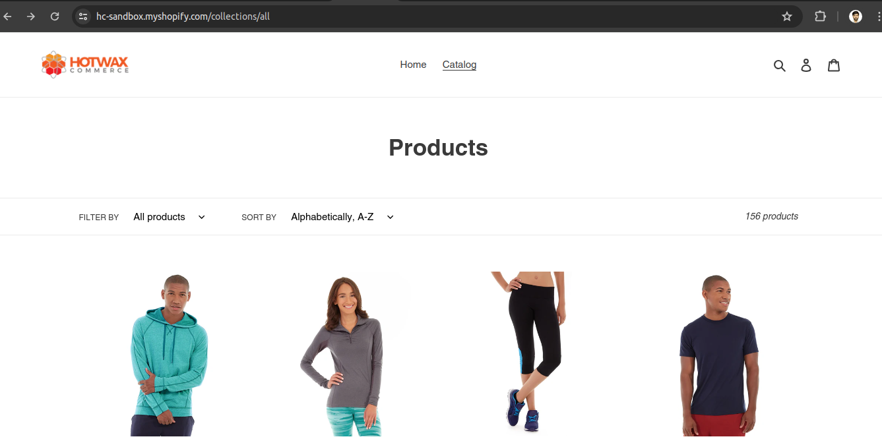

Step 2 - Add the item to cart and check out , fill payment details and place order

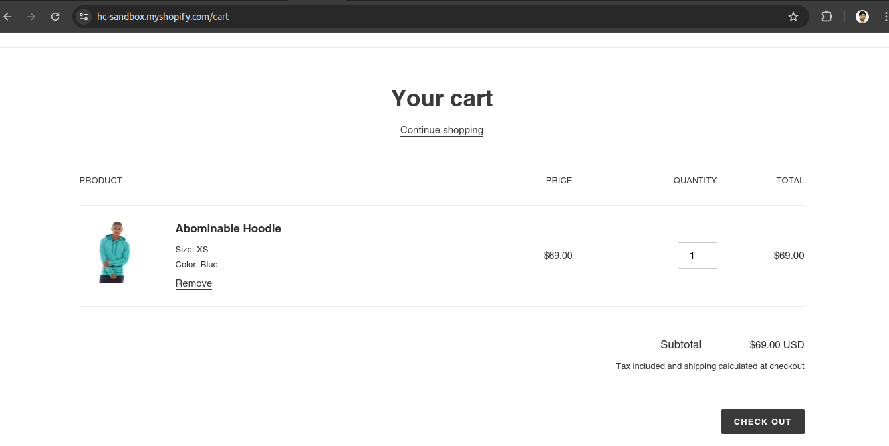

Step 3 - Order has been created

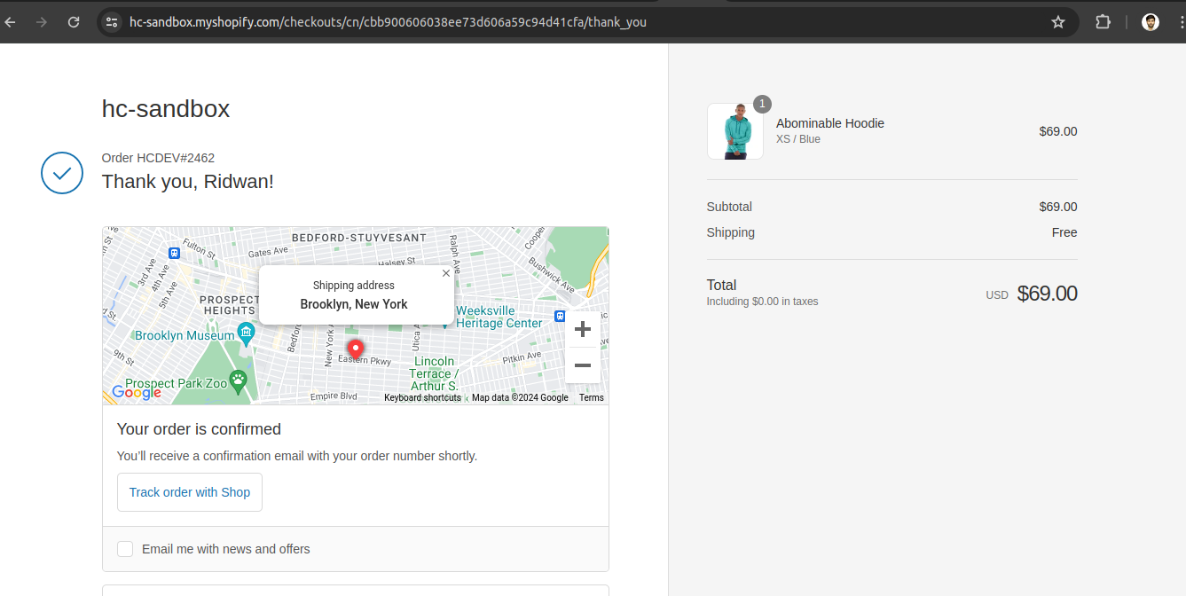

Step 4 - Open OMS and click on Order Management -> Sales Order - https://dev-oms.hotwax.io/commerce/control/FindOrder

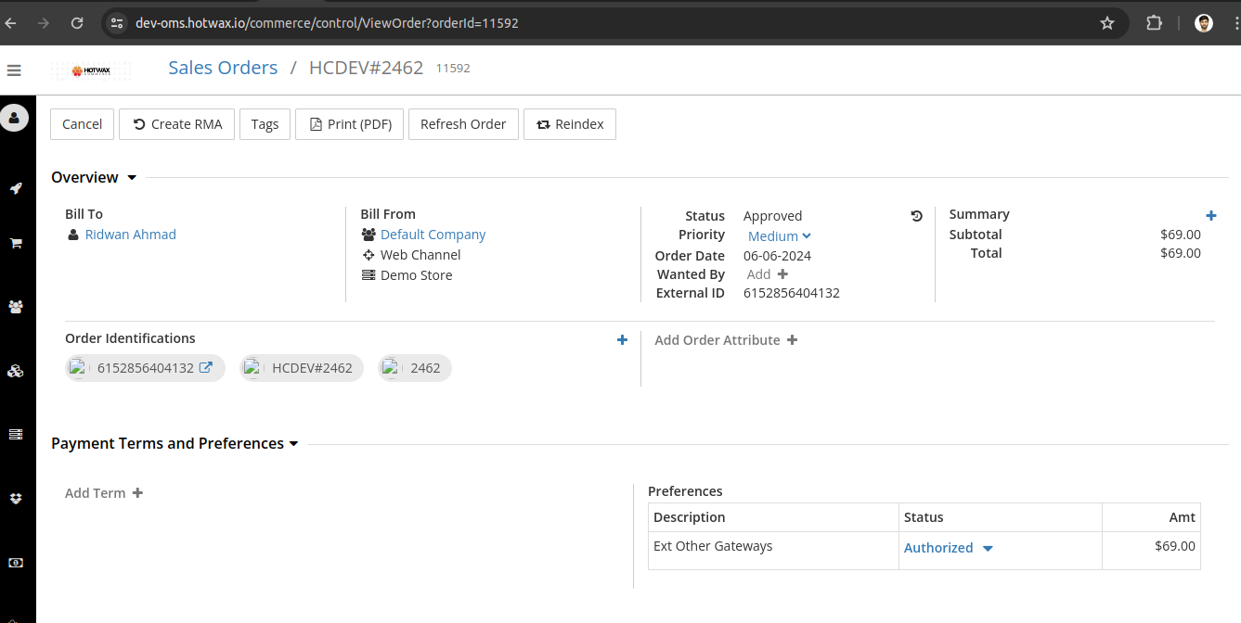

Step 5 - If we don’t wish to wait for Brokering queue to run and assign a facility , we can do that manually

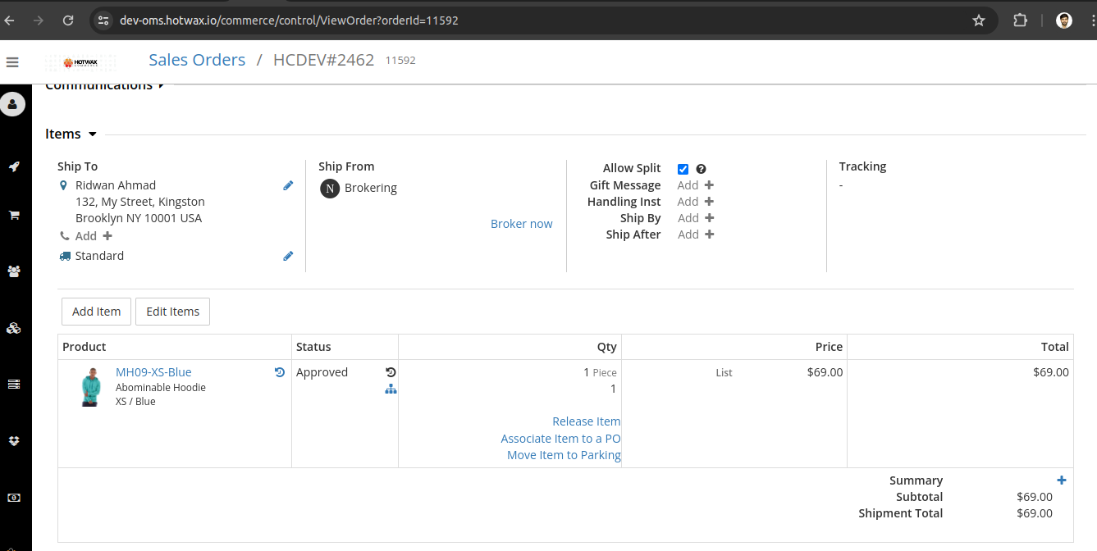

Step 6 - Item has been brokered to a facility successfully

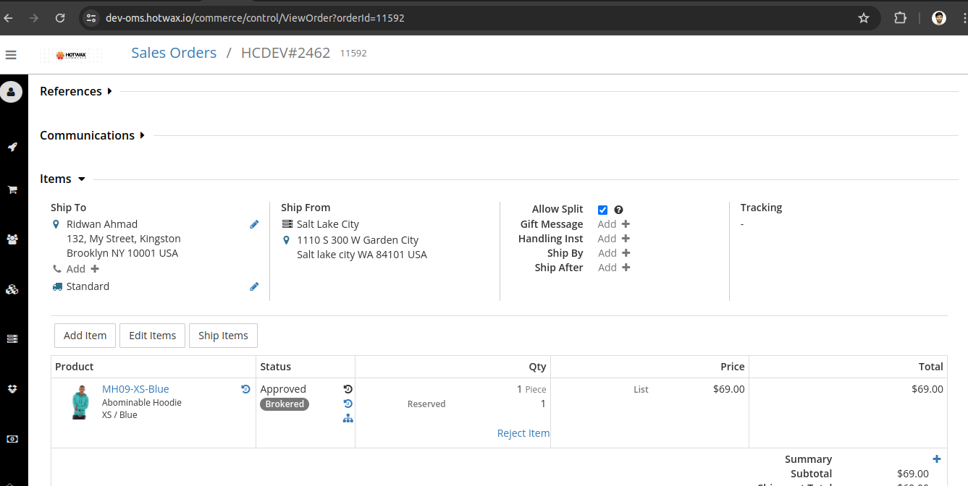

Step 7 - Open fullfillment integration app of Hotwax commerce and click print picklist to assign a picker - https://fulfillment.hotwax.io/open

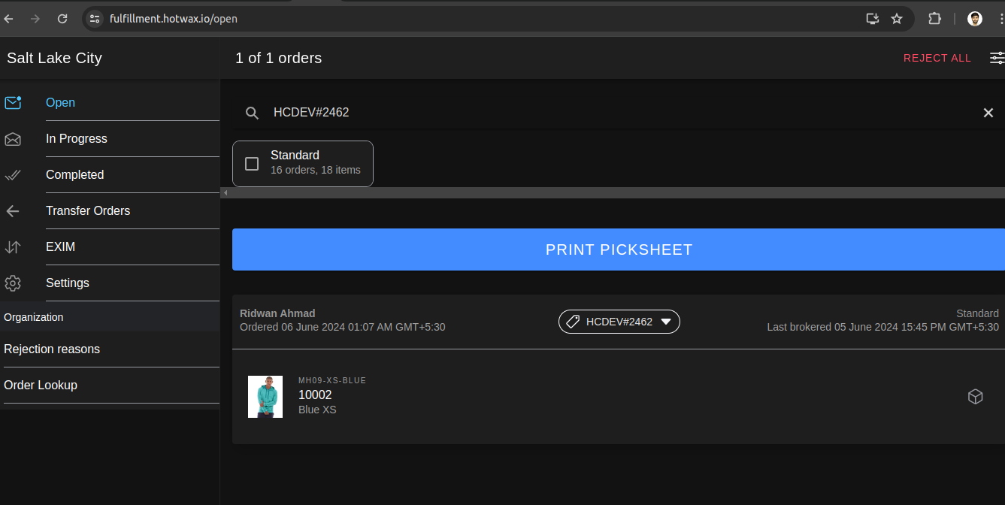

Step 8 - After assigning a picker , picklist is generated

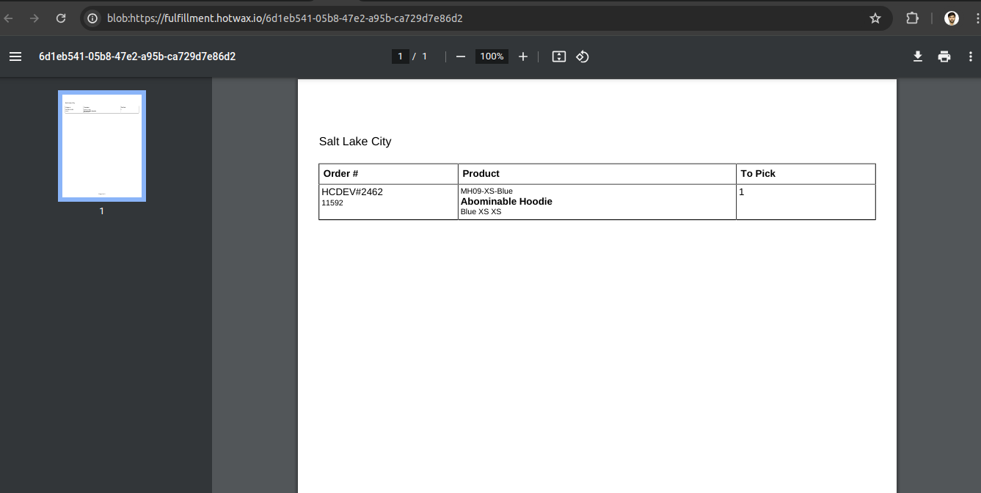

Step 9 - Pack the order for further process

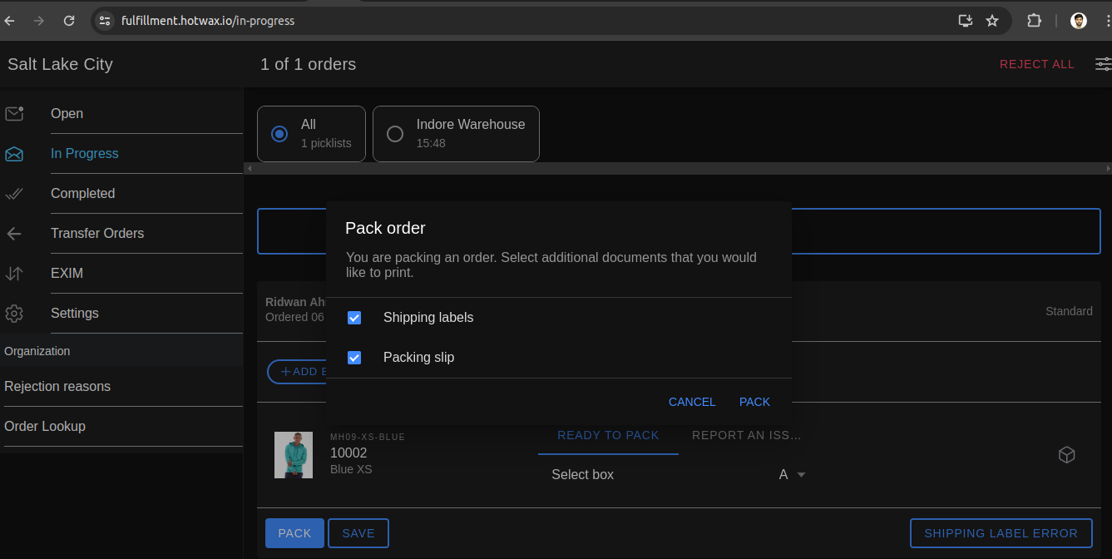

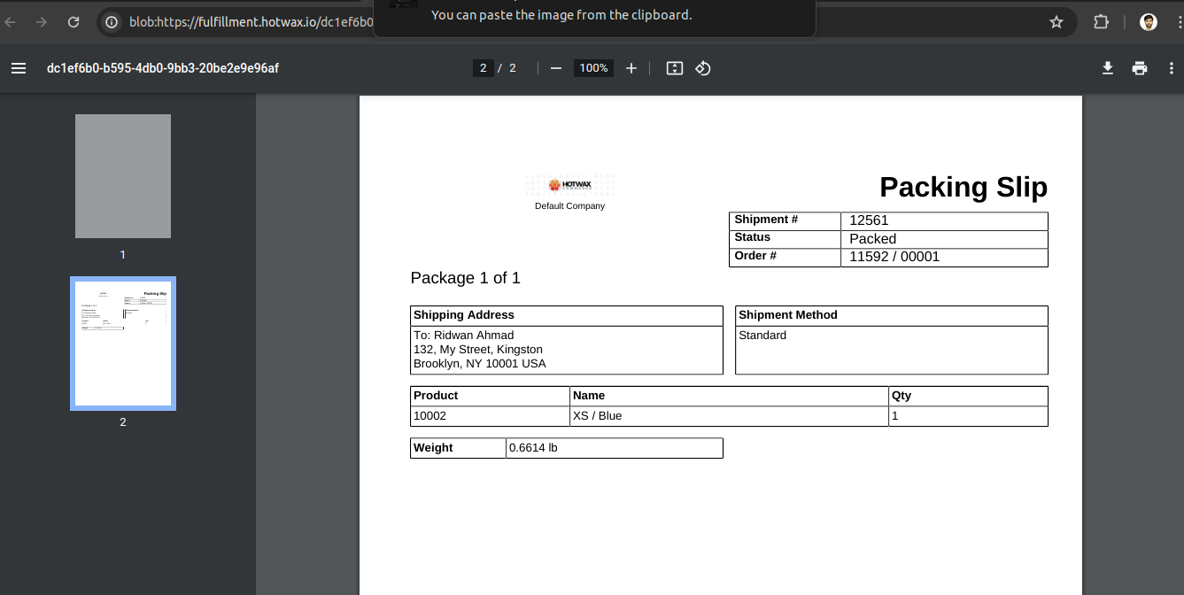

Step 10 - Click on ship now

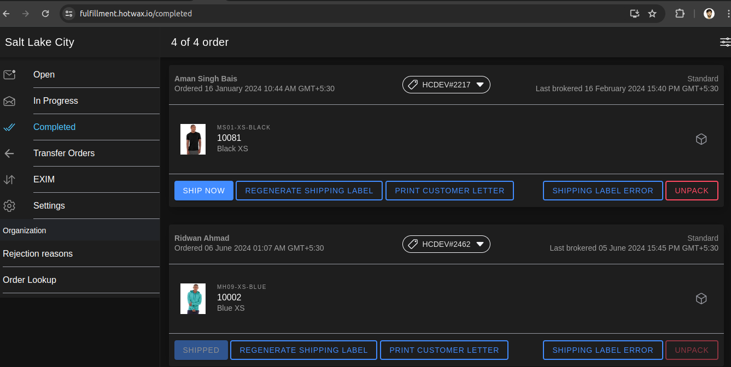

Step 11 - Confirm shipment by going to OMS

